

SCHEDULE A
Agent No. ________________
File No. __________________
Amount of Liability: _____________
Guarantee No: __________
Date of Guarantee: ______

1. Name of Assured: _______________.
2. The estate or interest in the land hereinafter described or referred to covered by this Guarantee is: _________________________
3. Title to said estate or interest at the date hereof is vested in: _______.
4. The land referred to in this Guarantee is situated in the State of Washington, County of ______________, and is described as follows: _______________________.
5. The Subject Contract is described as follows:
6. Assignments of Vendee’s interest if any, are described as follows:
7. Assignment of Vendor’s interest, if any, are described as follows:

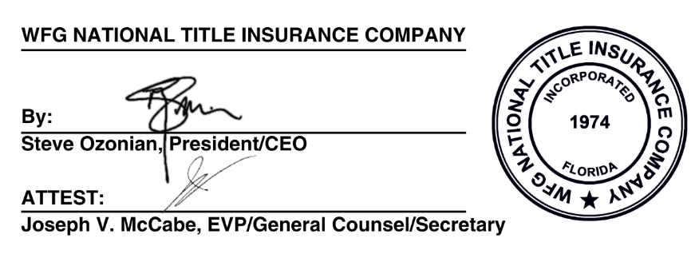
______________________
Authorized Countersignature

SCHEDULE B

1. Any defect, lien, encumbrance, adverse claim, or other matter that appears for the first time in the Public Records or is created, attaches, or is disclosed between the Commitment Date and the date on which all of the Schedule B, Part I Requirements are met.

2. Any facts, rights, interests, or claims that are not shown by the Public Records but that could be ascertained by an inspection of the Land or that may be asserted by persons in possession of the Land.

3. Any rights, interests or claims of parties in possession not shown by the public records.

4. Any lien, or right to a lien, for services, labor, materials or equipment in connection with improvements, repairs or renovations provided before, on, or after Date of Policy and not shown by the Public Records at Date of Policy.

5. Any encroachment, encumbrance, violation, conflict in boundary line(s), shortage in area, or adverse circumstance affecting the title that would be disclosed by an accurate and complete land survey and/or physical inspection of the land. The term "encroachment" includes encroachments of existing improvements located on the land onto adjoining land, and encroachments on the land of existing improvements located on adjoining land.

6. (a) Taxes or assessments that are not shown as existing liens by the records of any taxing authority that levies taxes or assessments on real property or by the Public Records; (b) assessments, or notices of such proceedings, whether or not shown by the records of such agency or by the Public Records.

7. Easements or claims of easements not shown by the public records.

8. (a) Unpatented mining claims; (b)reservations or exceptions in patents or in Acts authorizing the issuance thereof; and (c) Oil, natural gas, coal, fissionable materials or other minerals previously conveyed, leased or retained by prior owners, whether or not appearing in the Public Records or listed in Schedule B. The Company makes no representation as to the interests that are not listed.

9. Any adverse ownership claim by right of sovereignty to any portion of the lands insured hereunder, including tidelands, submerged, filled and artificially exposed lands and lands accreted to such lands or dispute as to the boundaries purportedly caused by a change in the location of any water body within or adjacent to the land.

10. Water rights, and claims or title to water, whether or not shown by the Public Records.

11. Any lien for service, installation, connection, maintenance, tap, capacity, or construction or water, electricity, natural gas or other utilities, or for garbage collection and disposal not shown by the Public Records.

SCHEDULE C

1. The names and addresses of persons who, as provided by R.C.W. § 61.30.040, are entitled to receive a copy of the notice of intent to forfeit are:

